MongoDB Assignment C
Haadiya Hasan Faruqi

Database : Assignment
Collection Name : students

- Find students with marks greater than 80.
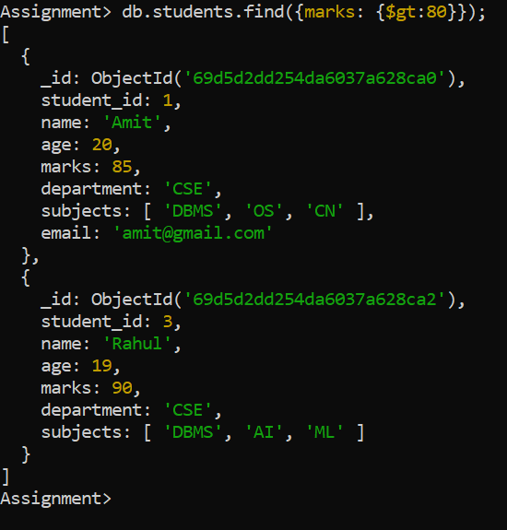

- Find students aged less than or equal to 20.
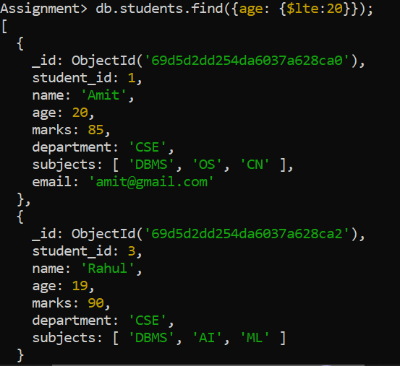

- Find students with marks between 70 and 85.
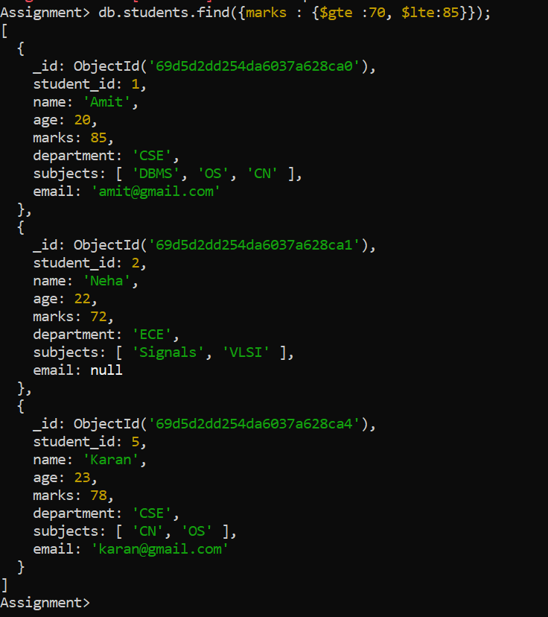

- Find students not belonging to the CSE department.
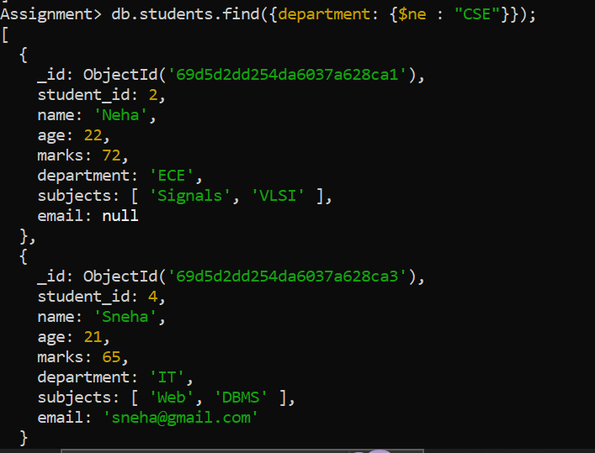

- Find students whose age is exactly 21.
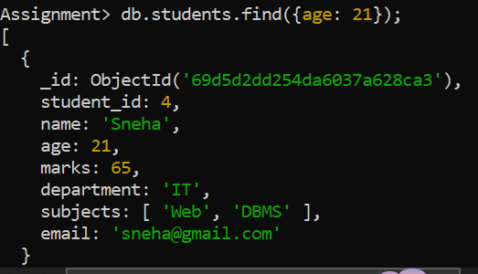

- Find students with marks less than 75.
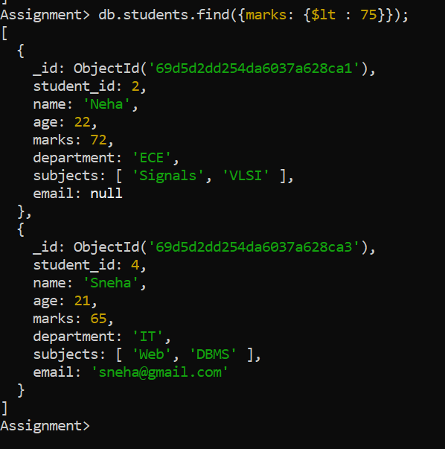

- Find students whose department is either CSE or IT.
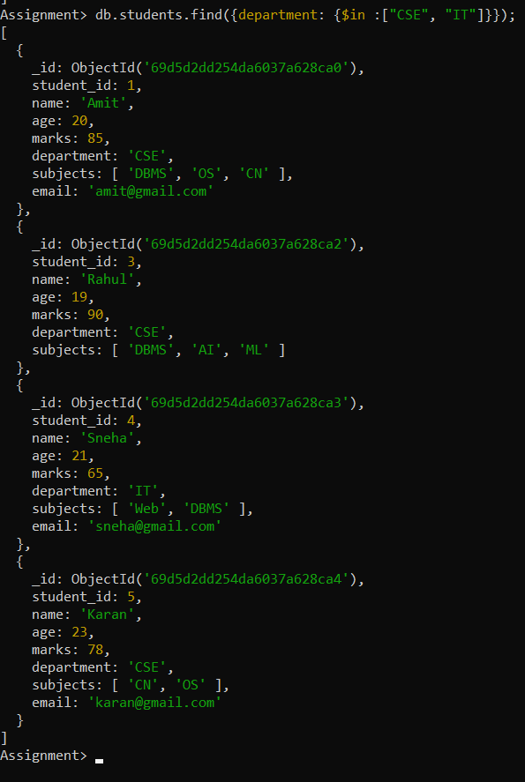

- Find CSE students with marks above 80.
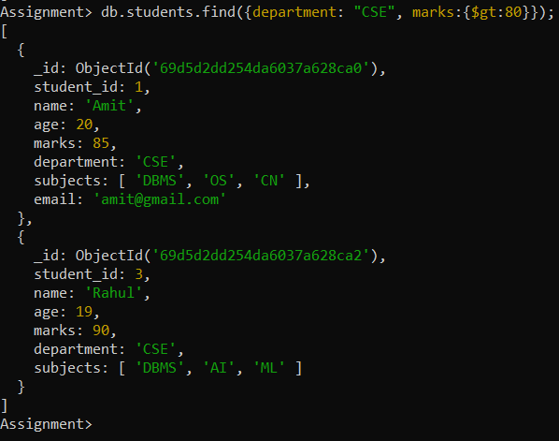
- Find students who are in CSE or have marks above 85.
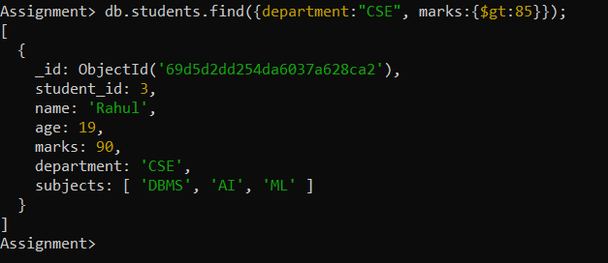

- Find students who are NOT in the IT department.
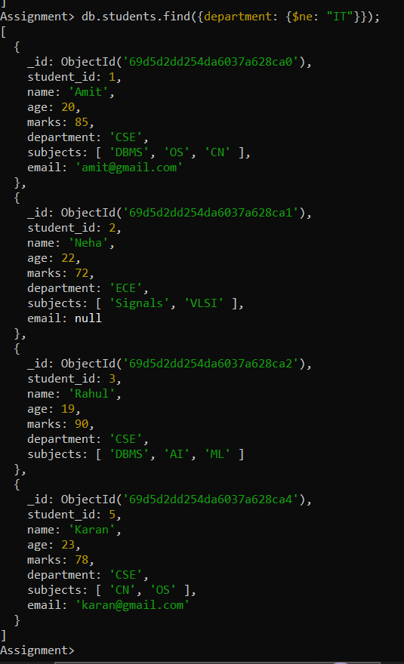

- Find students with marks not between 70 and 85.
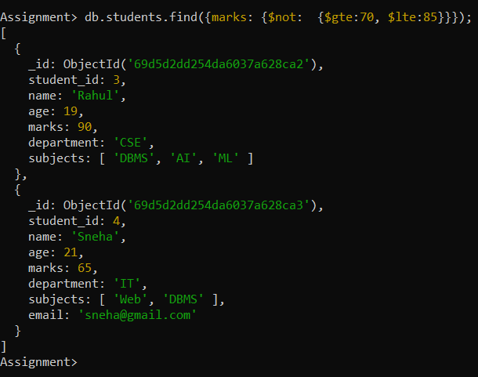

- Find students aged above 20 and not in ECE.
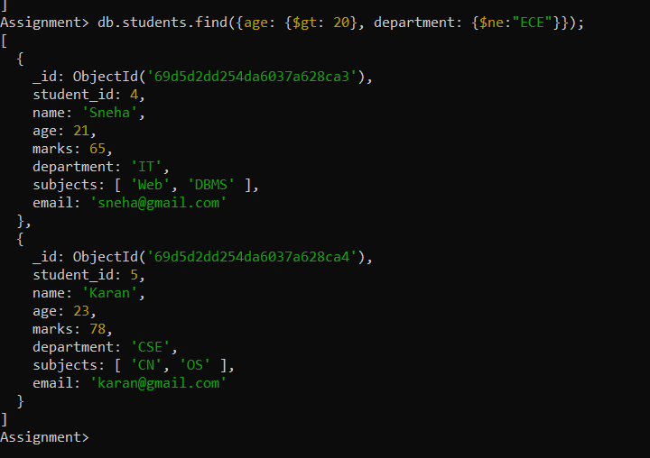

- Find students who are either IT students or have marks less than 70.
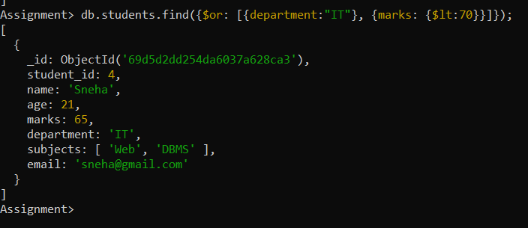

- Find students who are not CSE and not IT.
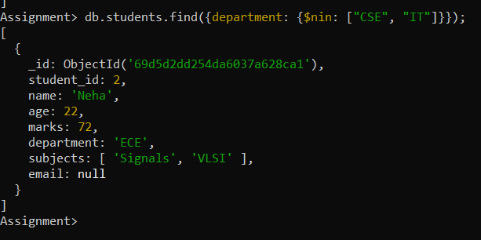

- Find students who have an email field.
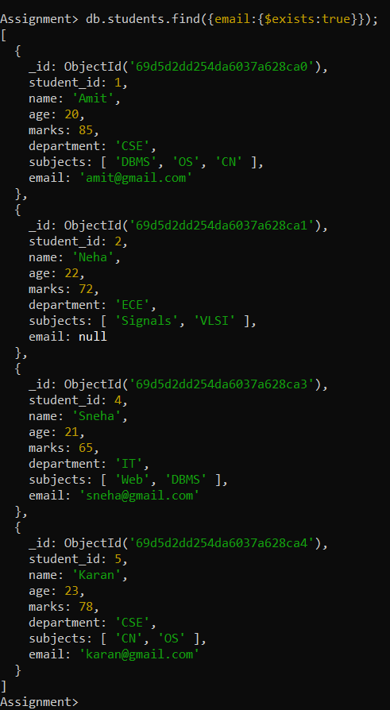

- Find students who do not have an email field.
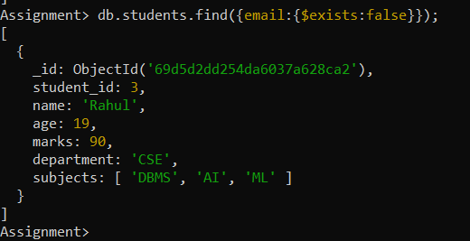

- Find students whose email value is null.
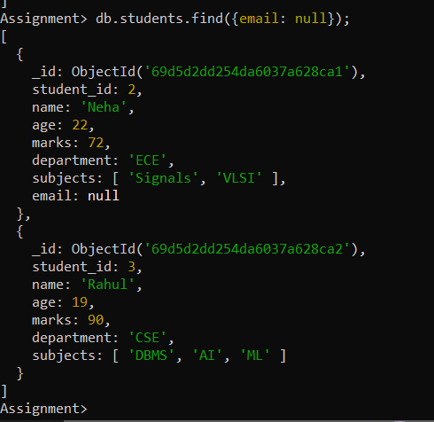

- Find students whose marks field is of type integer.
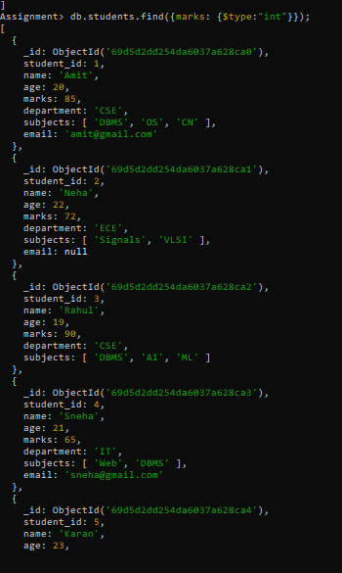

- Find students who have subjects’ field.
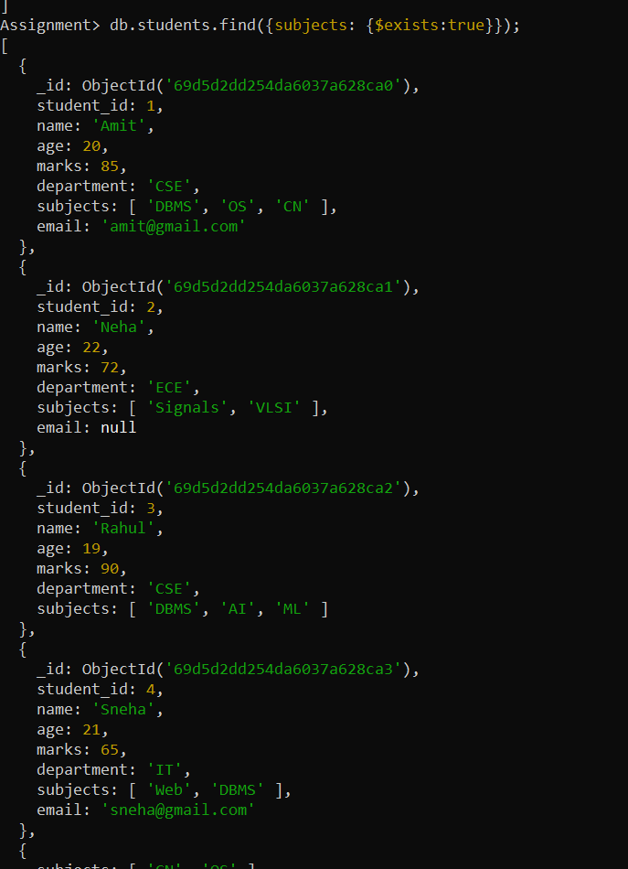

- Find students whose age field is missing.
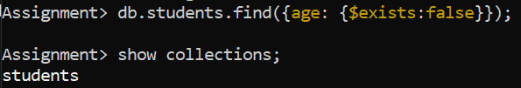

- Find students where marks modulo 5 equals 0.
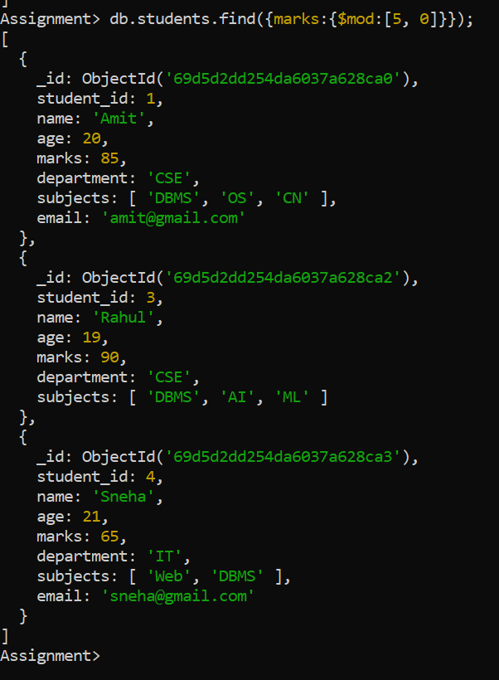

- Find students whose name starts with the letter “A”.
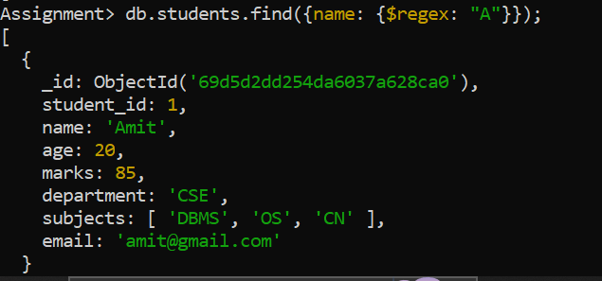

- Find students whose email ends with gmail.com.
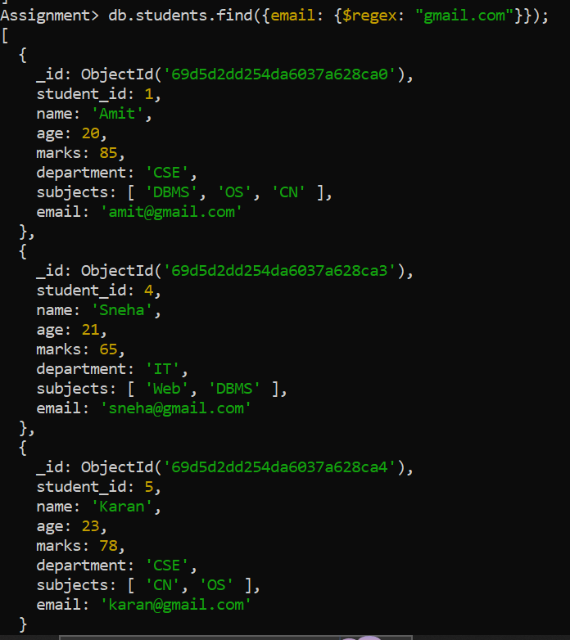

- Find students who have more than 2 subjects.
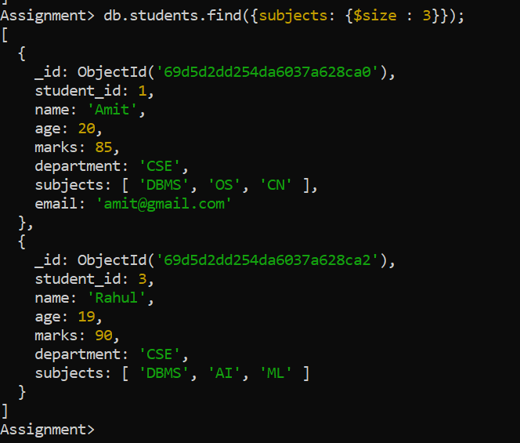
- Find students whose marks are greater than their age × 3.
